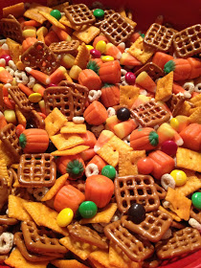**Harvest Trail Mix** 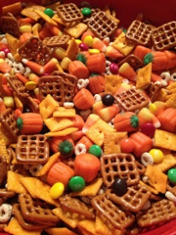

**Ingredients:**

**Fruit Loops Pretzels**

**Gold Fish**

**Chocolate Chips**

**Candy Pumpkins**

**Cheerios**

**Raisins**

1. Wash hands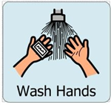
2. Get ingredients 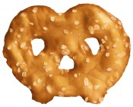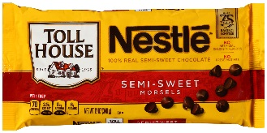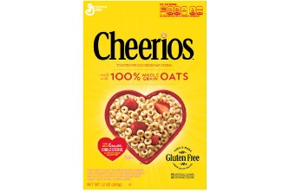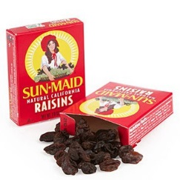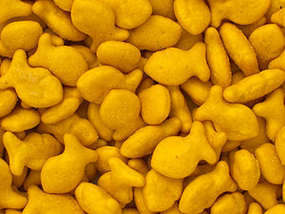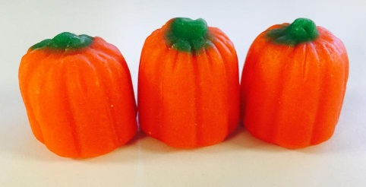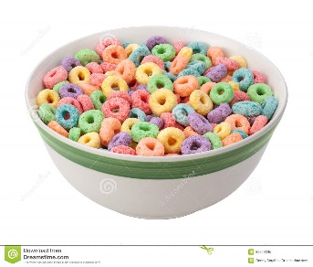

3. Measure ingredients in equal amounts and put into bowl. 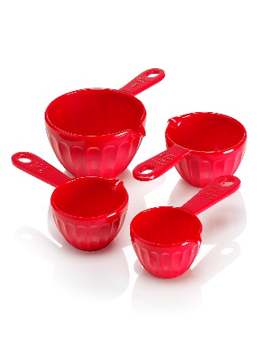

4. Stir ingredients to mix them up. 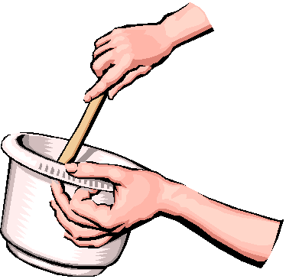

5. Scoop out trail mix and put onto plate. 

6. Eat and enjoy! 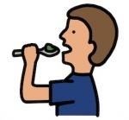

Did you like it? ☺ ☹

Yes No